(Approx. 233 words)

S2dio Products
By George Harding, Treasurer, Tucson Computer Society
www.aztcs.org

I received a media box from this company after CES. It contained two products and a catalog.

POWERQ

This is a handy way to charge most of your devices. It is a wall plug with a USB-A port. You can use the cable that came with your device and just plug PowerQ into the wall. There is plenty of power to charge most devices.

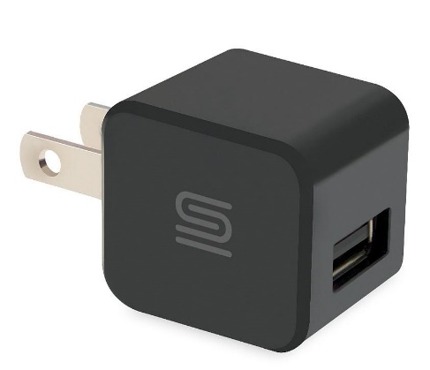

The circuitry includes auto-sense, which protects your device from over-charging. You don’t have to worry about it catching fire, because auto-sense will stop the charging function when your device is fully charged.

PowerQ is small, only slightly larger than a one-inch cube. It is a handy traveling companion, easily fitting into a briefcase or purse.

AUTOPOWER PD30

This is another handy charger, made for easy use in your car. It fits snugly into the power outlet that’s available in all cars (it was used as a cigarette lighter in the old days). It contains a USB-C port for fast charging.

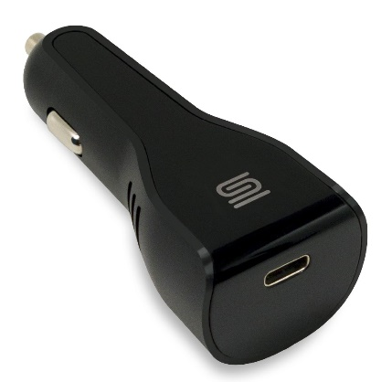

The charging capacity is 30W at 15V, enough to charge most devices, including smart phones, tablets and select laptops.

The circuitry protects against over-voltage, over-current and short circuit situations.

The unit’s size is perfect for stowing in the glove box for those occasions when you need a quick charge.

S2dio www.s2diousa.com
Price at Amazon: PowerQ $12, AUTOPOWER PD30 $15

